**Protect patient information**

Microsoft Cloud for Healthcare helps support your customers for privacy, security, compliance, and interoperability of health data. It focuses on protecting patient information through the following ways:

Security - Protect against the latest threats with intelligent tools to help prevent attacks and react quickly to security events. For more information, see Security in Microsoft Cloud for Healthcare.

Compliance - Stay up to date with the latest requirements with the most comprehensive set of cloud compliance offerings. For more information, see Compliance in Microsoft Cloud for Healthcare.

Privacy - Maintain control of your data with confidence knowing that your data won't be used for commercial purposes.

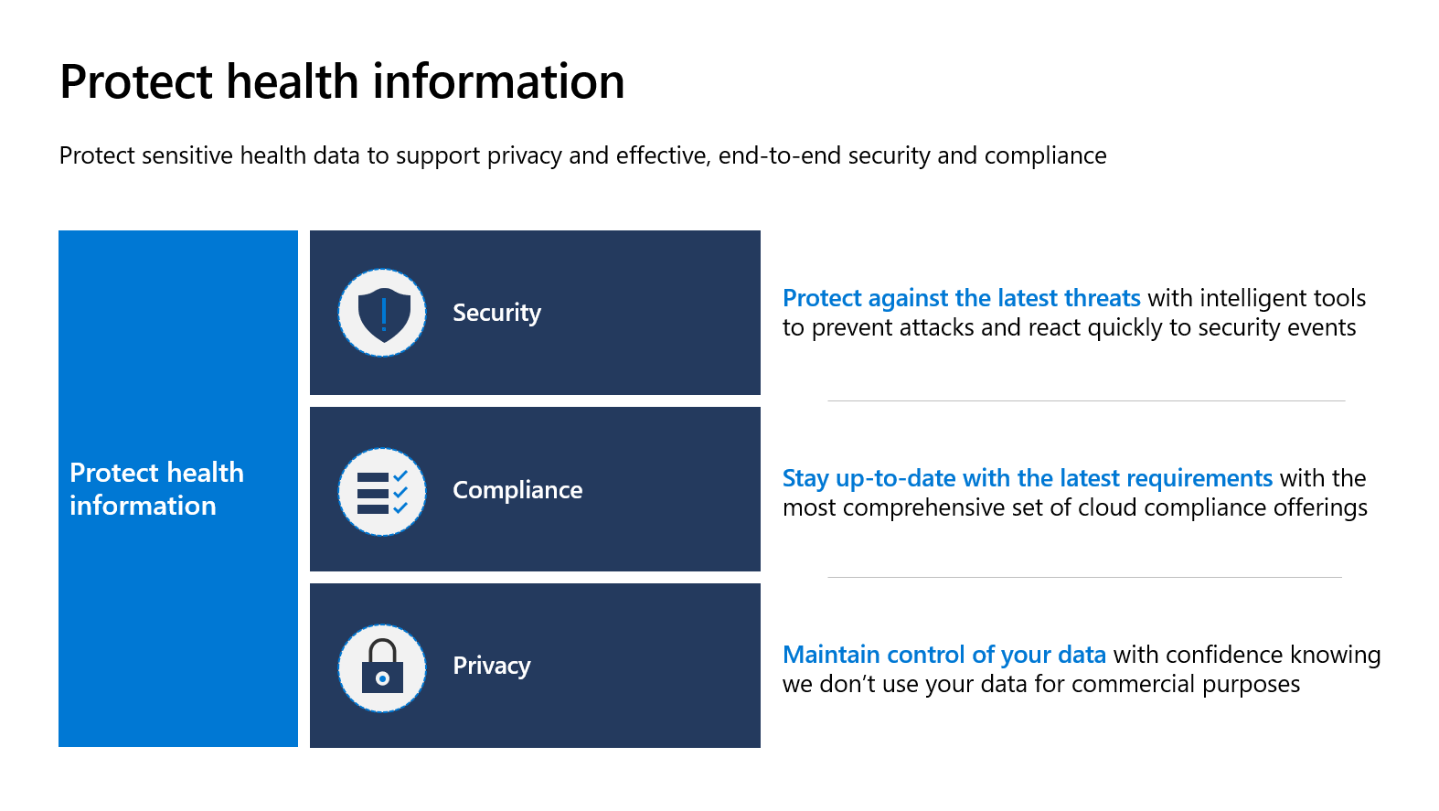

Next unit: Conceptual architecture